# SHAREPOINT ASSIGNMENT

**Step1:Open sharepoint**

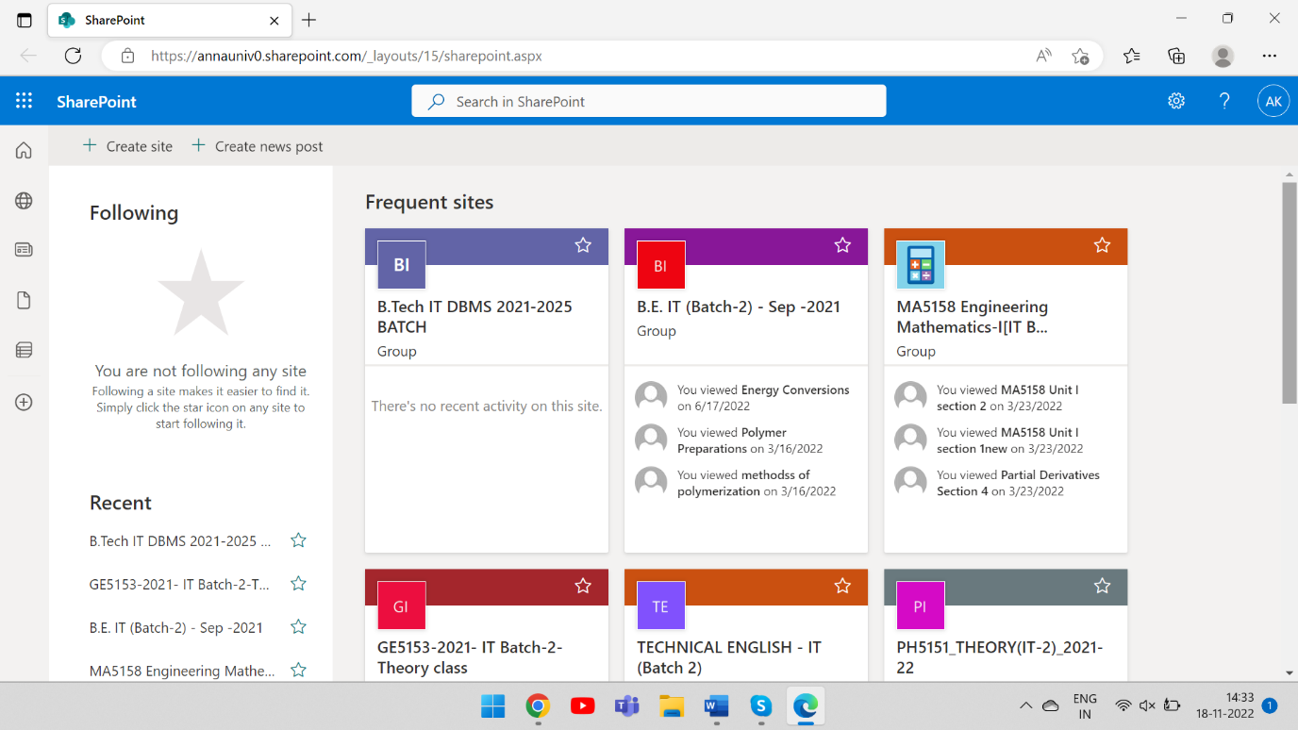

**Step2:Create a team site**

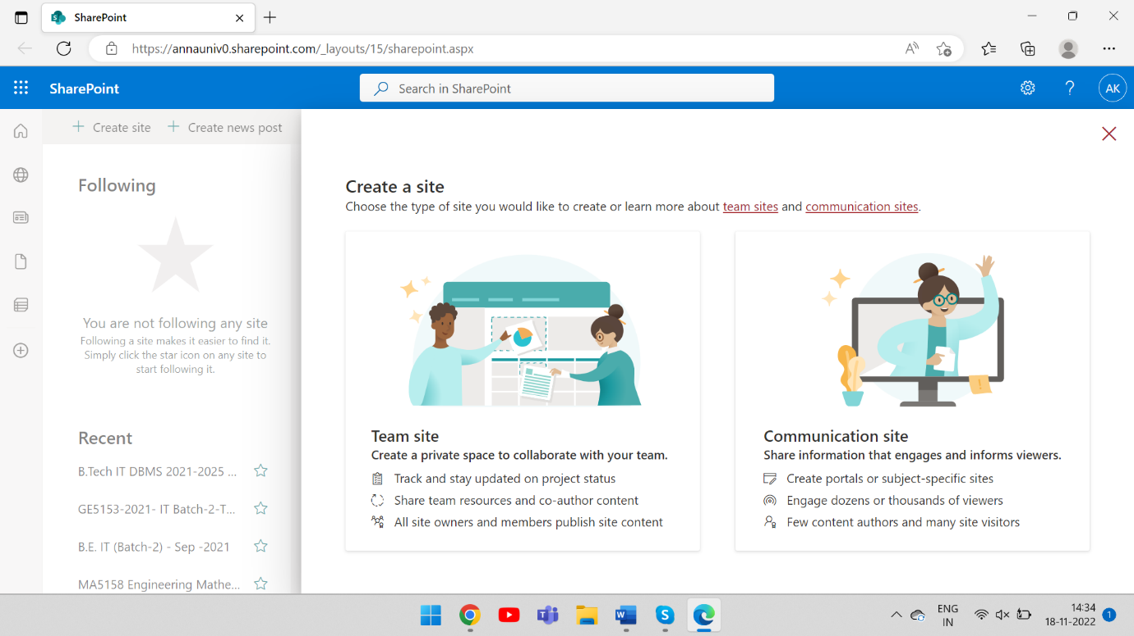

**Step 3: Name your site and enter your description.**

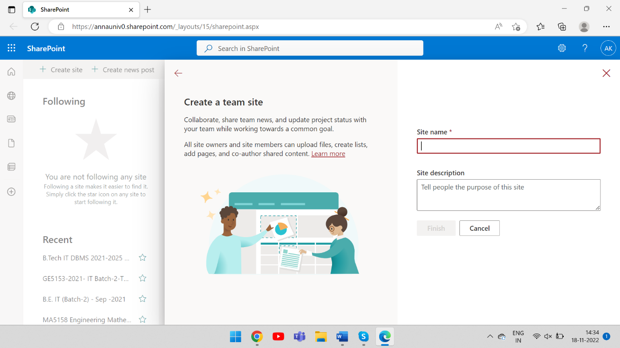

**Step 4:Click Finish**

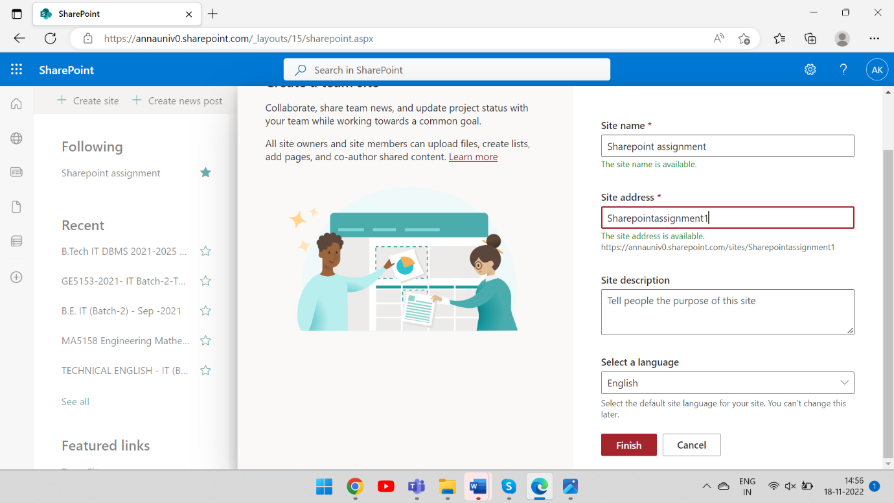

**Step 5: Site has been created successfully**

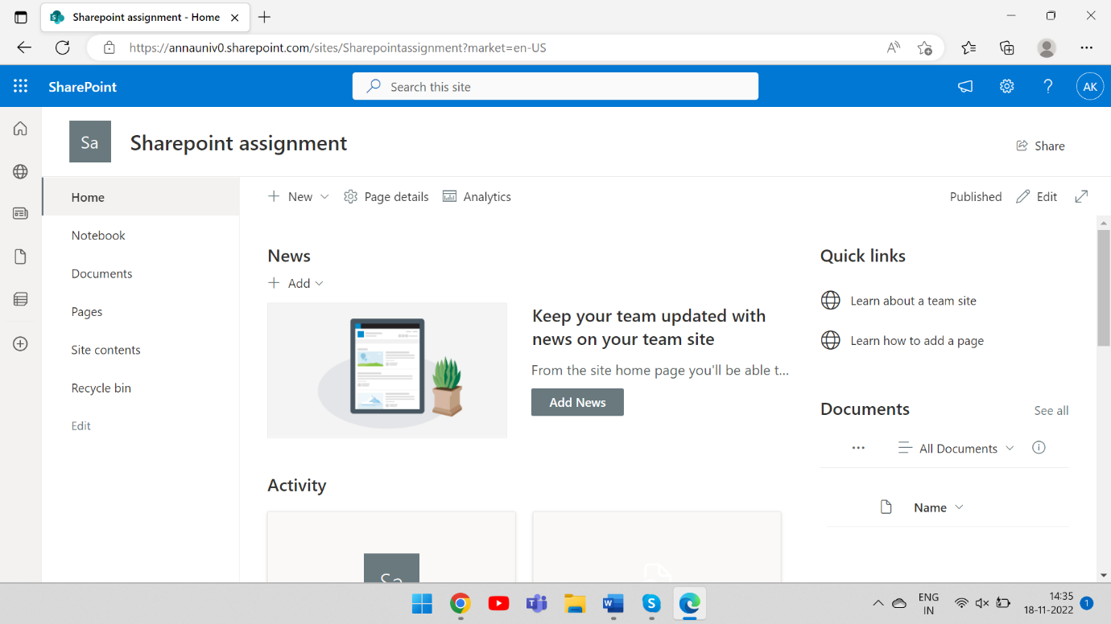

**Step 6: Upload a document**

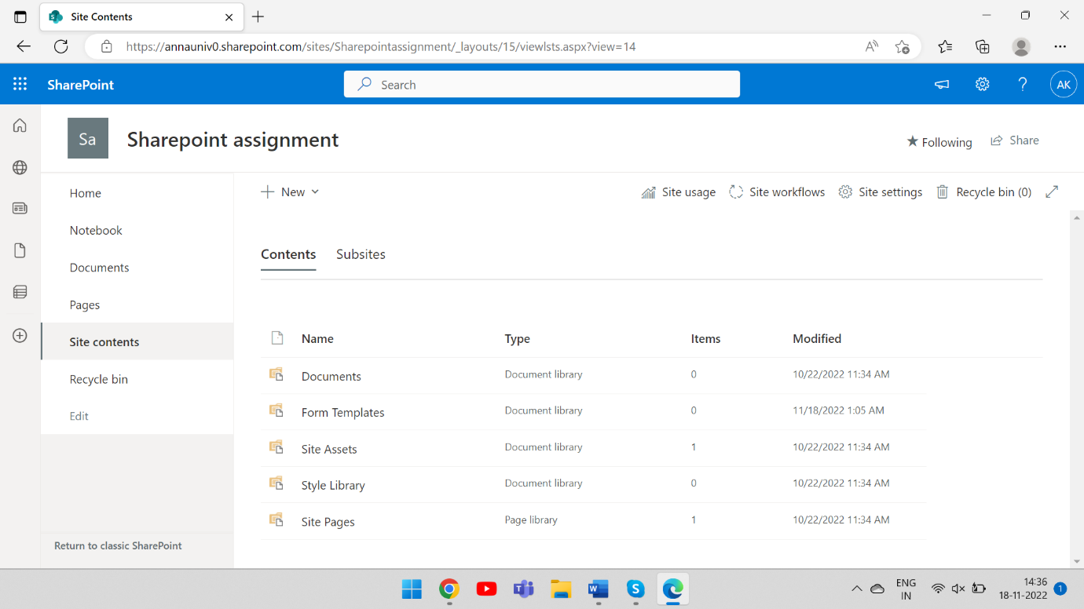

**Step 7: Document has been uploaded**

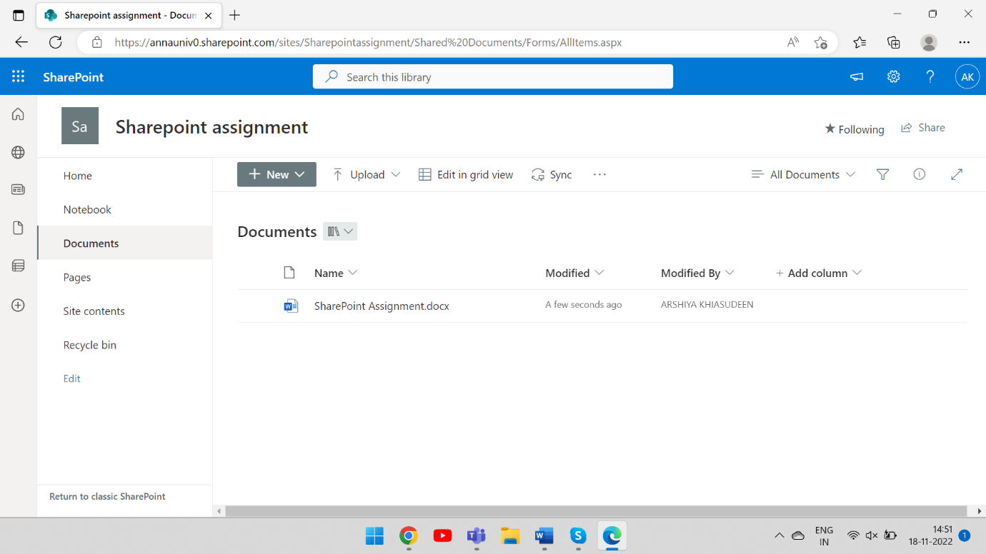

# Step 8: Share with your teammates.

